Architect

A Grand Design

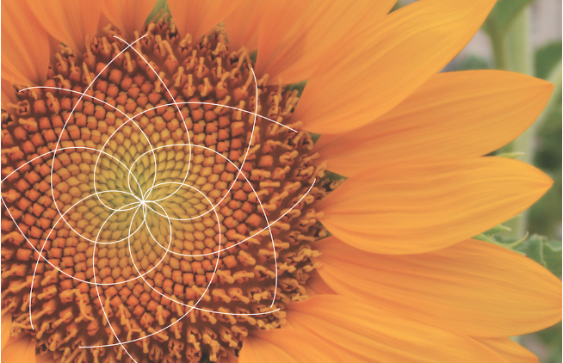

M Croteau

www.vocebonita.xyz

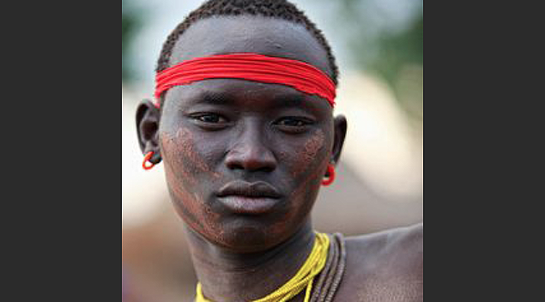**Was each Race created?**

**Yes.Evolution is not real...**

**Evolution does not exist**.

We were all created, **all created independently...**

...each race was created independently in order to create a unique and different World, a World that could not be created with one race. Each one of us Original in Design.

**Original in Design?** There are distinct differences between all cultures here on Earth. Observe a few cultures some of which are neighboring and ask how did they come to be? Was each race created independently, or one created with adaption and evolution? Let’s take a look…

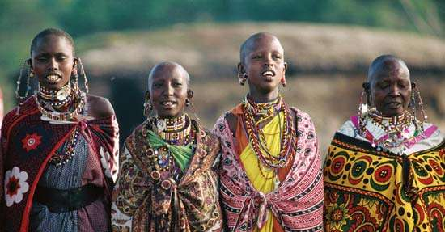Africa

India

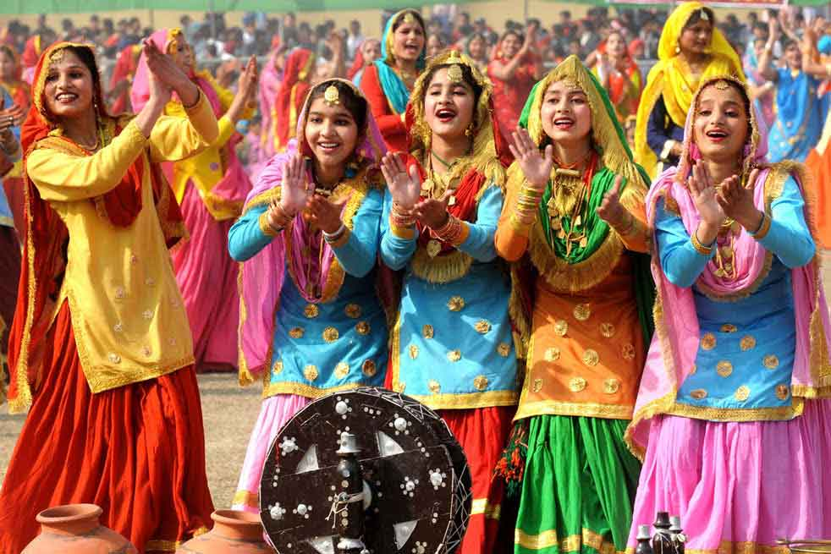

Germany



Saudi Arabia

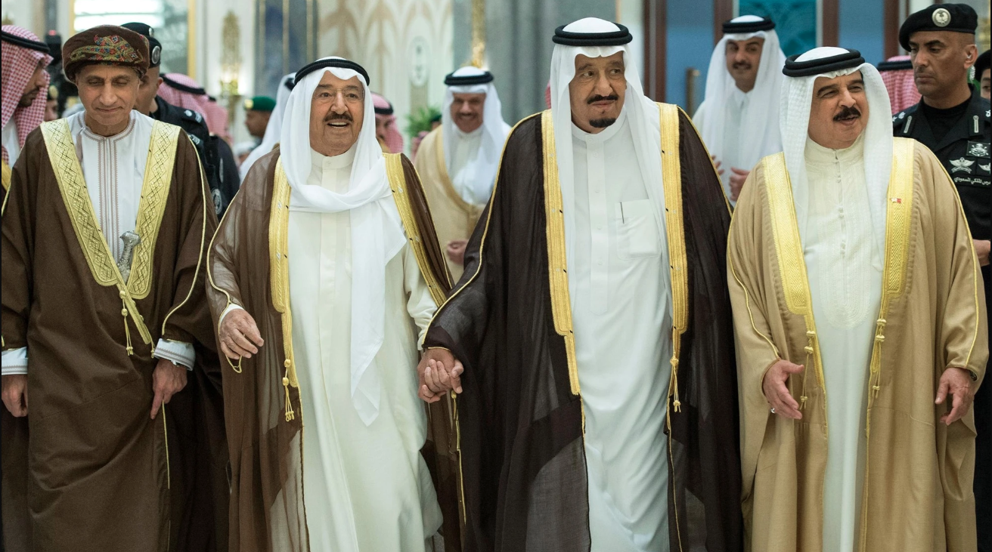

Russia

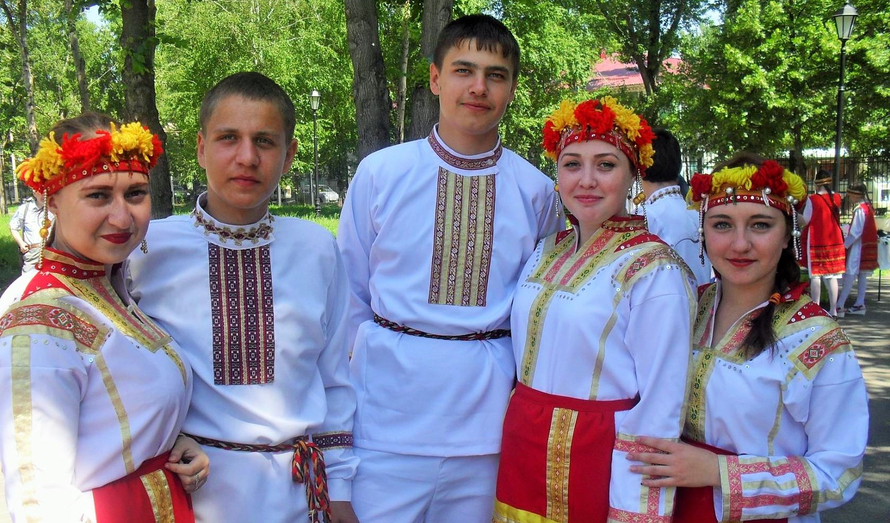

China



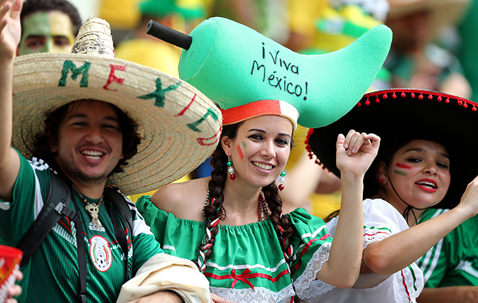Mexico

Brazil



We are all different.

...It is plain as day.

*There is no environmental component, weather pattern or diet that shaped us individual people over time*. Evolution does not exist.

In detail, observing the images on the previous pages, you can start to think about the cultures, architecture, food and lives of the people. Each are different in their own way. Start to combine the cultures and people and you have something new, something unique, something different, something that the our Grand Architect could not create with one race.

**Do you understand?** Let me explain:

*There is only so much preference information that can be stored within us.*

If one race or culture occupied the planet, all organizations of people would look the same. However, mix in some variety, more than one race and you have the possibility of cultures working together to create a unique civilization, a unique World. Like ingredients to an ultimate recipe, we, each group or race of people are designed to part of a Grand Design…

*… This includes architecture, music, culinary arts, spirits, dance and movement how we interact, anything and everything, we have the possibility of creating a unique and different World, it can happen so long as every human being is allowed to live freely. Change could happen, and it could happen organically.*

So you want to challenge the existence of God and the idea of creationism…

**The**

**Existence**

**of God...**

It can be proven within the definitive design in nature, and mathematics within the design. Take a look at the following image.

Ask how did it come to be?

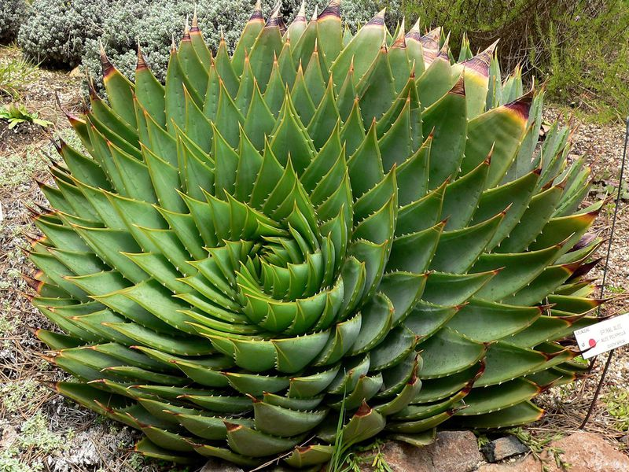

Do you see uniformity and the math within the design? You should, it’s there. There is no challenging it. If math is visible within the design, that means that it was created. No questioning it. **There is uniformity in the design of many things on our beautiful planet, including us.**

**More proof**

**that we**

**were created.**

**Lets do an exercise…**

...I want you to take a look at your hand. Look at your hand from the side, start to wiggle your fingers and move your hand back and forth.

Do this in front of a plant.



It’s important that you perform this exercise next to or in front of a plant. Spend at least 15 seconds performing this exercise and ask the following questions while performing this, “Does the hand belong, is the human hand foreign?”



The hand is foreign, the human existence is foreign, we all together everything human is foreign.

We did not grow or originate from Earth. We were created by God. We did not evolve. **We were created**.

Let’s consider the single celled organism theory, that we all originated including animal life from a single celled organism. The amount of data that would need to reside within the starting single celled organism would be very large.

*It cannot be stressed enough that* ***life on Earth would be very very strange if evolution were true****. Evolution does not exist, we did not originate from a single celled organism*, **we were all created**.

There is only so much preference data that can be stored within DNA…

**The**

**Solar System...**

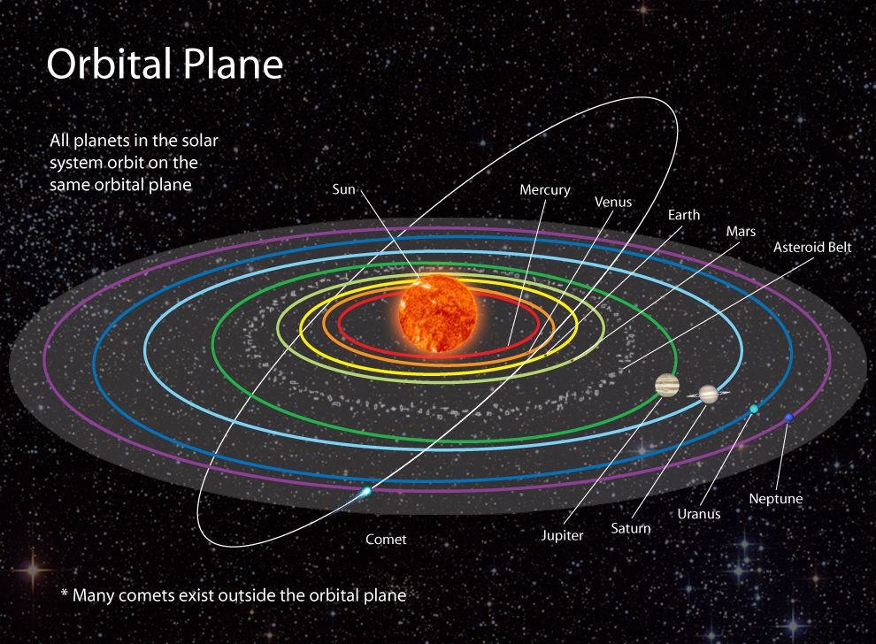

And in a short synopsis… The solar system consists of 8 planets that orbit the Sun. These planets orbit in a horizontal fashion. While orbiting these planets tilt and rotate… its systematic, uniform in design. An Architect is at play. It was created, we were created.

**In conclusion,**

**again...**

**what is our purpose…**

... Again, there are differences in preferences between different cultures or organizations of people. If two cultures worked together to create, that something would turn out to be unique, something different, a unique Blend. Blends can be something as simple as food or drink, something like Cherry Sprite or Ginger Ale with Lemonade both can be seen as **Blends**.

We can go even a little further in our conclusion...

**You don’t even have to believe in intercultural relationships in order to believe in the Grand Design**. It does however need to be allowed to happen.

A unique world has an opportunity of happening.

It has an opportunity…

**!ඔබට ස්තුතියි**

This is “Thank you!” in Sinhala, language of Sri Lanka. It is probably the most interesting language...

Blacks before women → buy plants

Whites before women → buy plants

Thou shall promote and foster ones culture

Thou shall encourage disaggregated love

173